Afeefah Manzoor

ITN277: Forensics 2

Email, Phone Scenario

* What file(s) on the Windows Mobile device contain the most information about communications (e.g., e-mails, text messages, calls)?

I believe the emails contain the most information.

* Is there any indication that steps were taken to delete or conceal e-mails or text messages? If so, what were they?

They were steps taken to remove, delete messages transpired. I was able to find a JavaScript code that removed files and plenty of other files were overridden as well.

* Please provide any information that might help investigators identify potential accomplices?

In the emails that were recovered from the phone, there was a mention of Porter Kniaght, and joe Javits. They also mentioned a first name of Matt that may deal with transportation and a user that goes by goatboy2009, goat boy, gboy, and [goatboy2009@gmail.com](mailto:goatboy2009@gmail.com), and another email user that went by bmoreagent. A person also had left text messages with the CLSID of C9E37C15-DF92-4727-85D6-72E5EEB6995A and the cellular tapi service provider of 5FF7-4bcl-80F6-5DA7870B. Also in an email the number +1(203)645-2774 was sent.

* Do you find any specific references to other potential sources of digital evidence that investigators might be interested in knowing about (e.g., servers, mobile devices)?

Other potential sources of evidence could be found in the device with the phone number of +1(203)645-2774 and

The phone which had left had left text messages with the CLSID of C9E37C15-DF92-4727-85D6-72E5EEB6995A and the cellular tapi service provider of 5FF7-4bcl-80F6-5DA7870B

* Please provide a summary of Web browsing activities on the mobile device.

The web browsing showed that they had visited several sites pertaining to a crash that had happened in the Hudson, the coast guard, smuggling and visited cdn.turner.com 83 times.

* Based on your previous findings, please determine what Constantine Petersburg and his cohorts were trying to do.

It seems like Petersburg and his cohorts were trying to smuggle people in from the Hudson through Fort McHenry and possibly sell their organs.

* While the above information is necessary, it is of no value if it cannot be tied to a specific individual. Investigators suspect that Constantine Petersburg was involved in illegal activities. However, they need proof of this. Please provide detailed information based on your findings that would tie Constantine Petersburg (or others) to the contents of this Windows Mobile device as well as Outlook e-mail file.

All shown below.

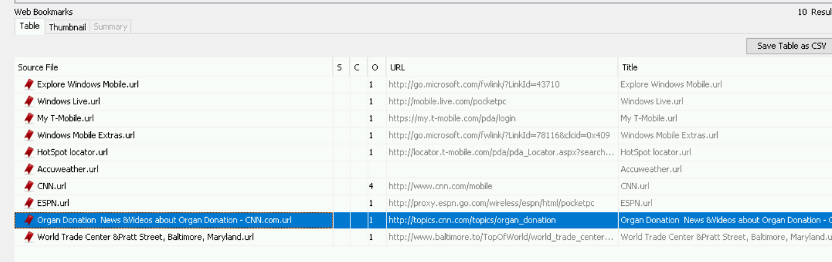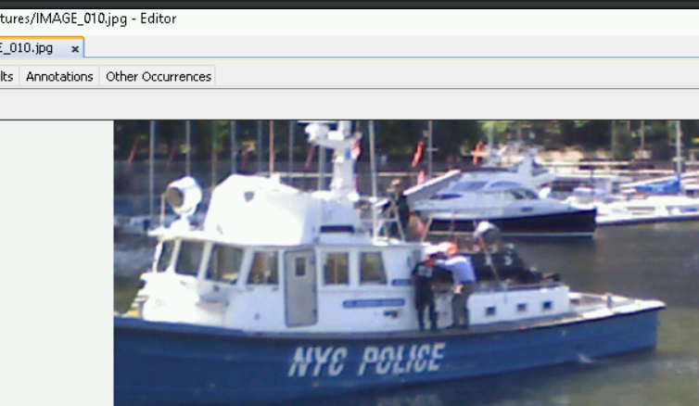Photo taken of officers taken on scene.

Websites favorited. Most interesting bookmark is the Organ Donation linked from CNN and a separate CNN page bookmarked.

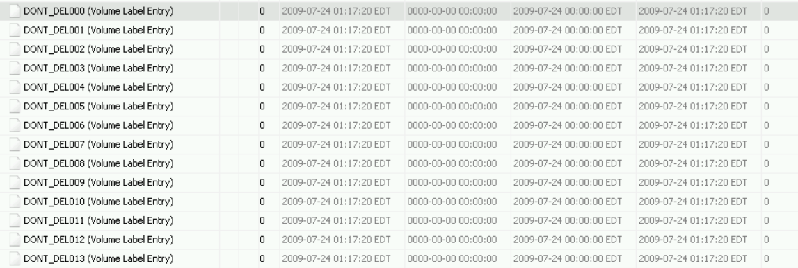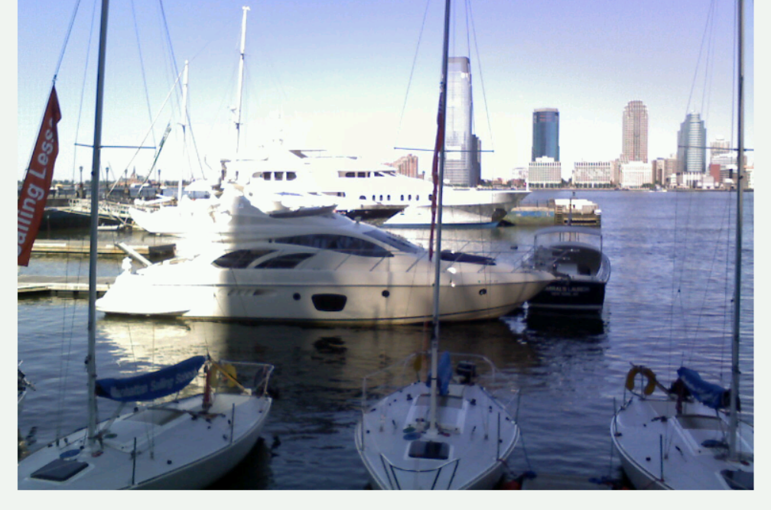picture of the harbor from what seems either before the police arrived or after the police left.

13 Files that have been deleted that are labels DON’T_DEL.

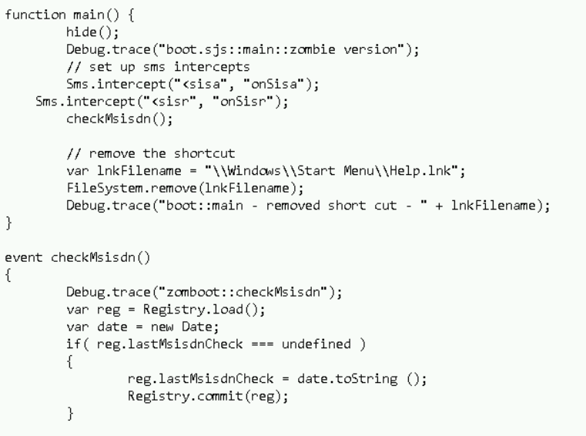a Javascript code written to delete files.

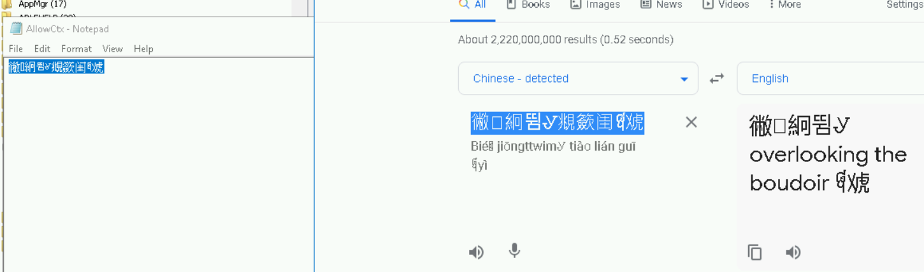

A text file written in Chinese that translates to “overlooking the boudoir”

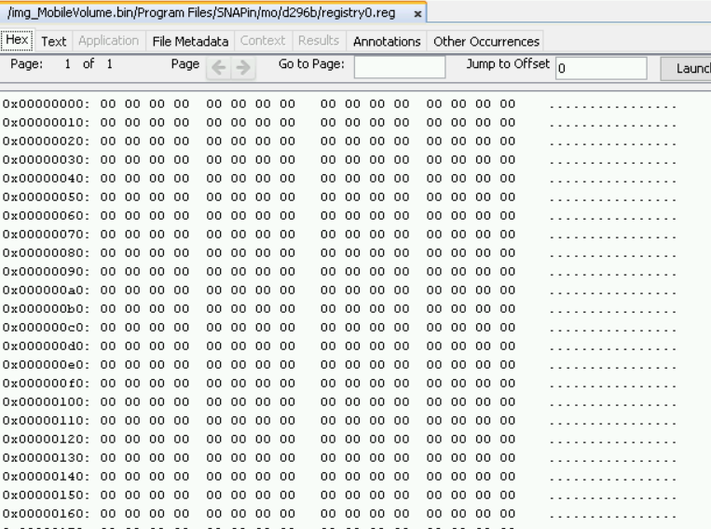

A registry file that was overwritten.

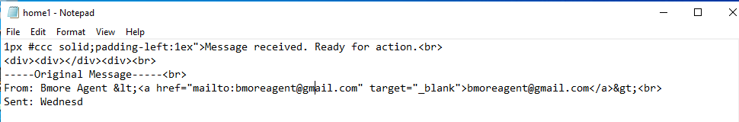

Email sent from [bmoreagent@gmail.com](mailto:bmoreagent@gmail.com) saying “message received, ready for action” that was sent on wed.

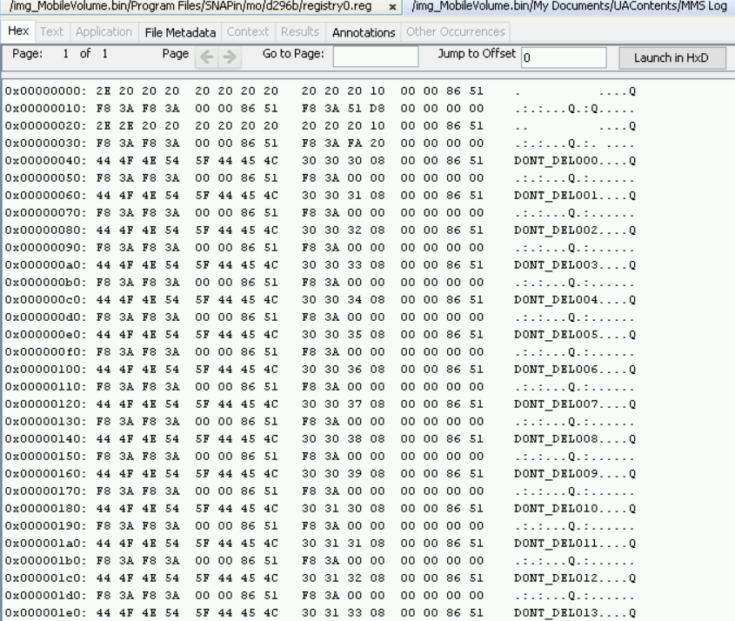

mms log that has all the deleted files written in it.

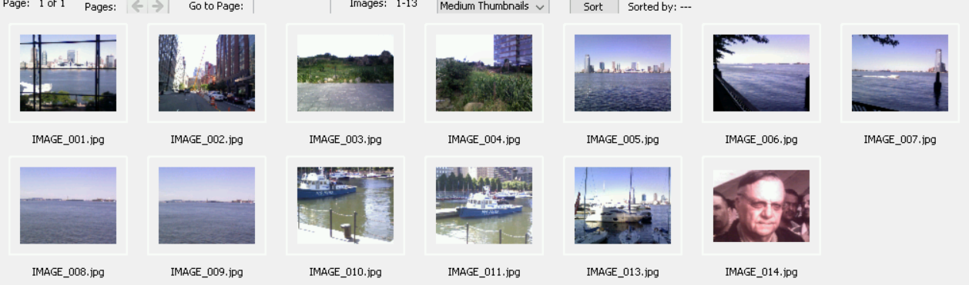

Images taken.

Below are correspondence.

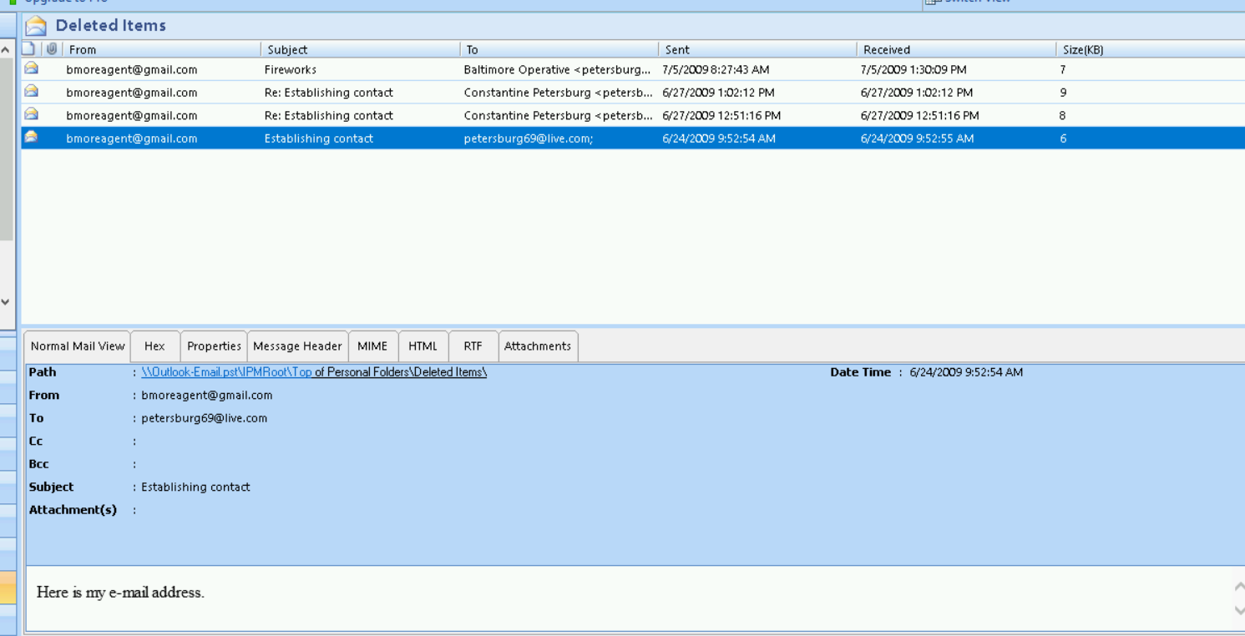

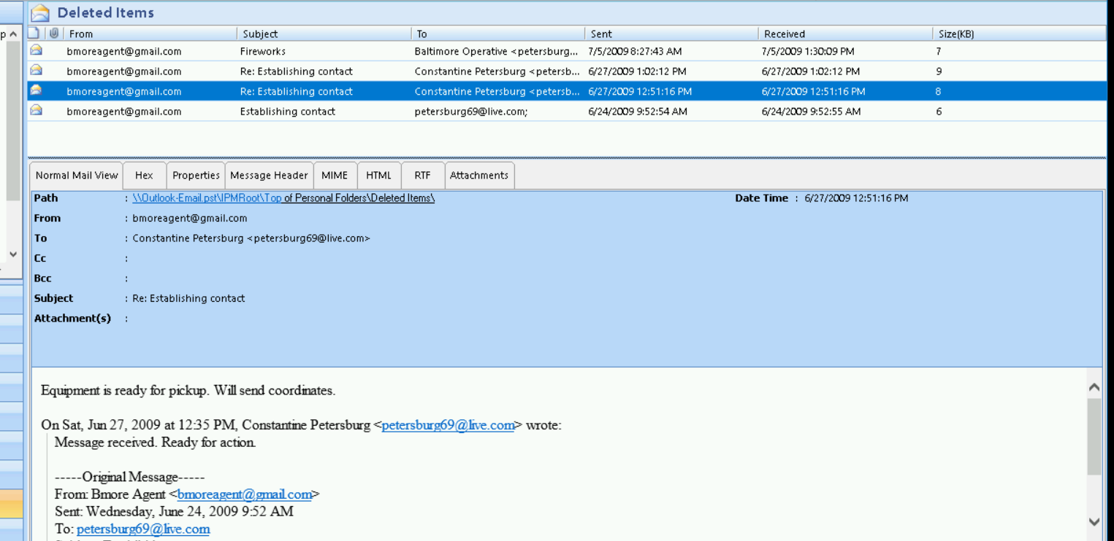

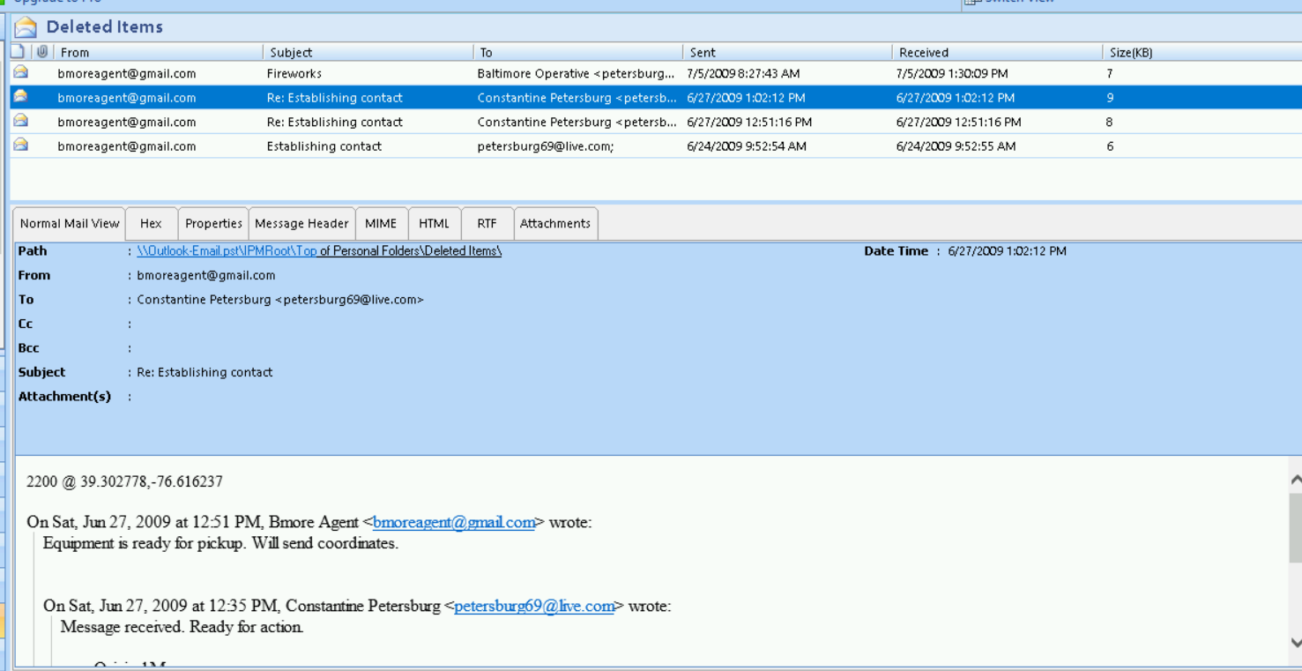

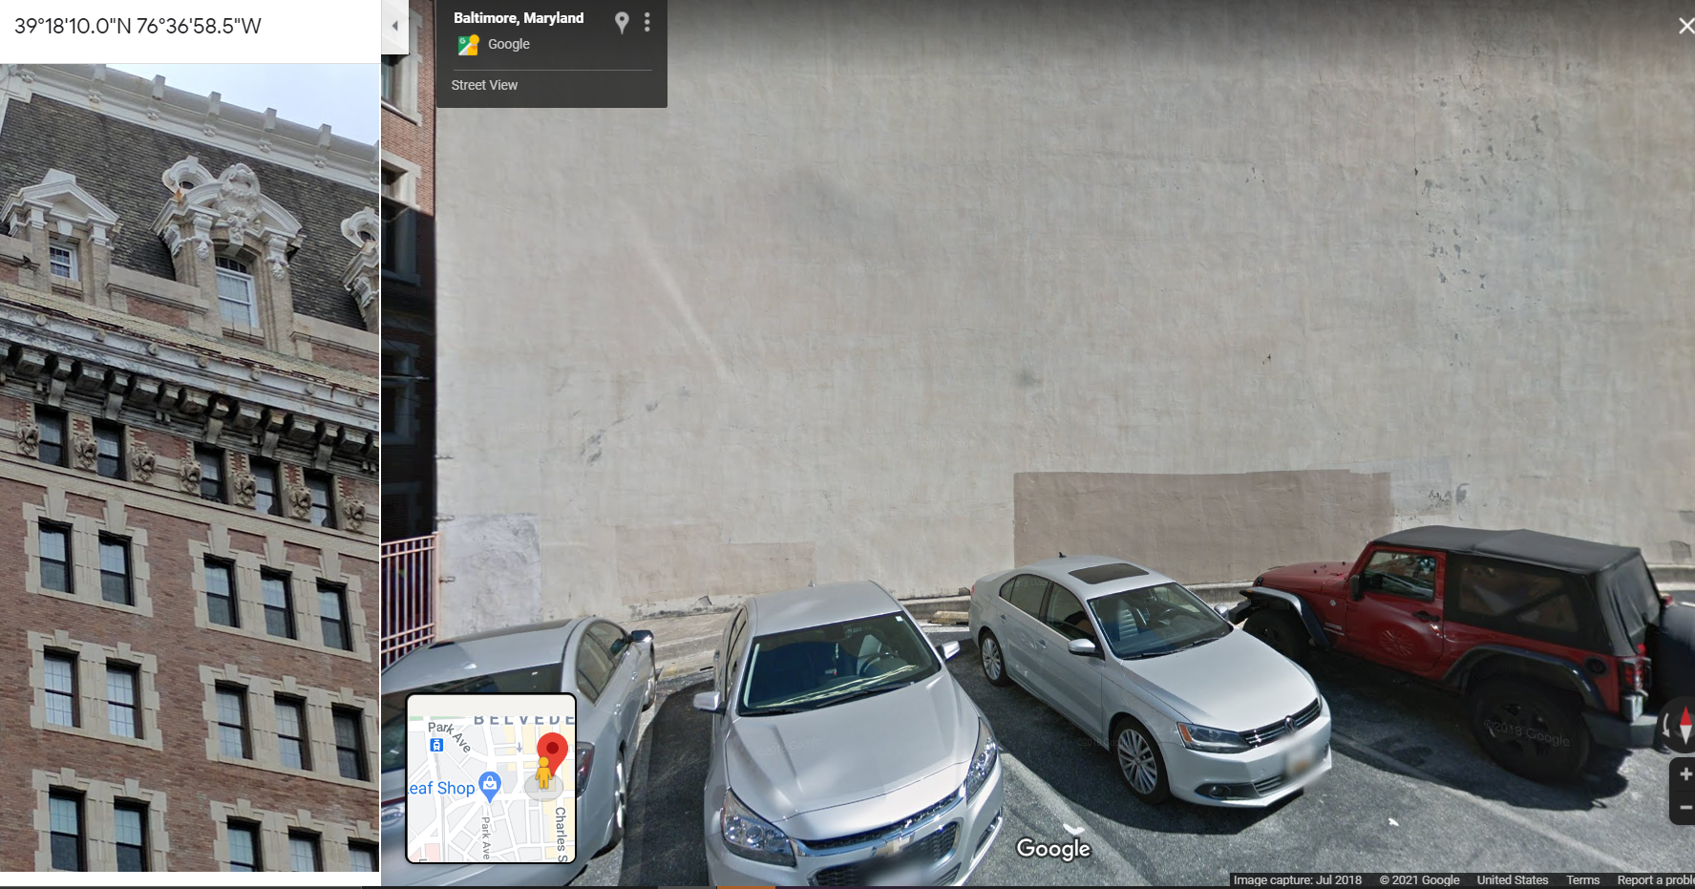

Coordinates that were sent

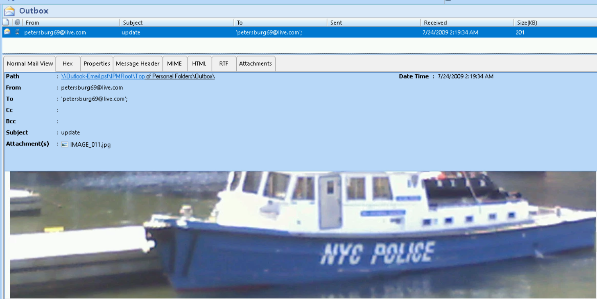Image of police at the harbour

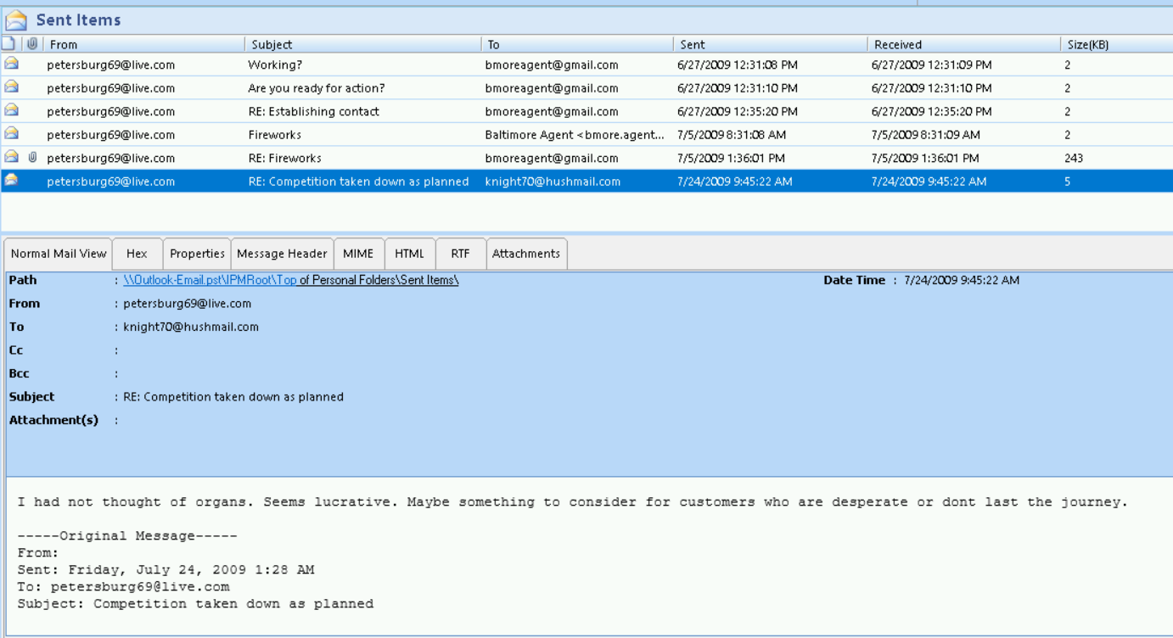

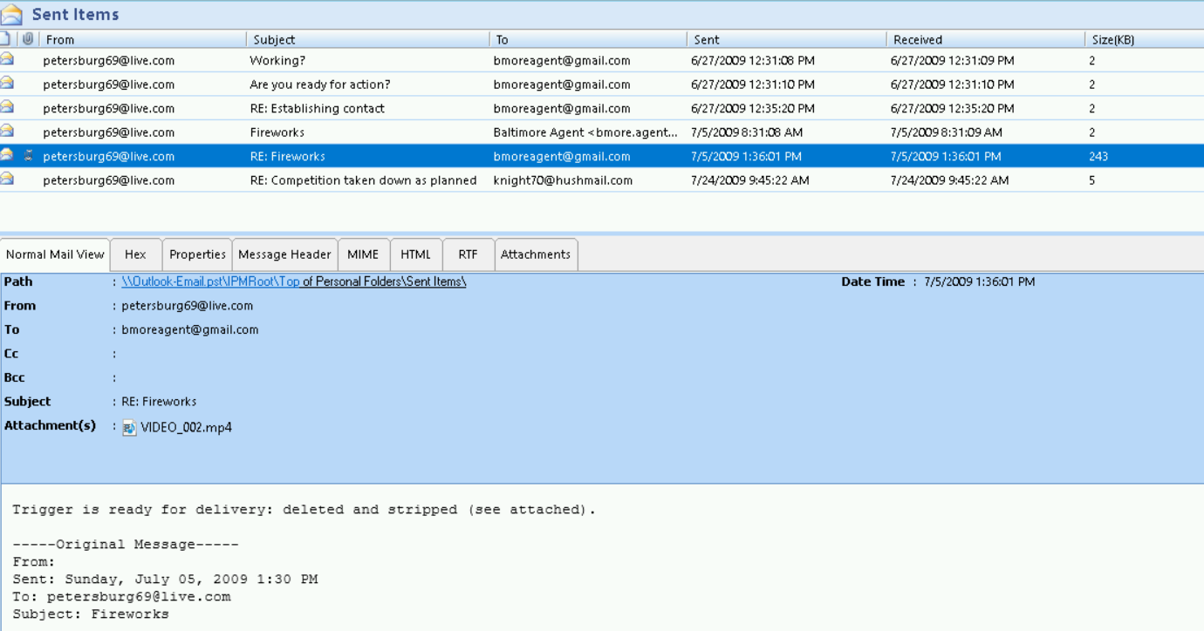

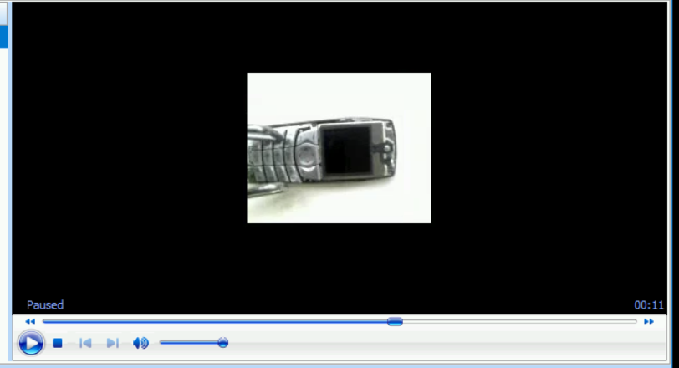this is the attachment

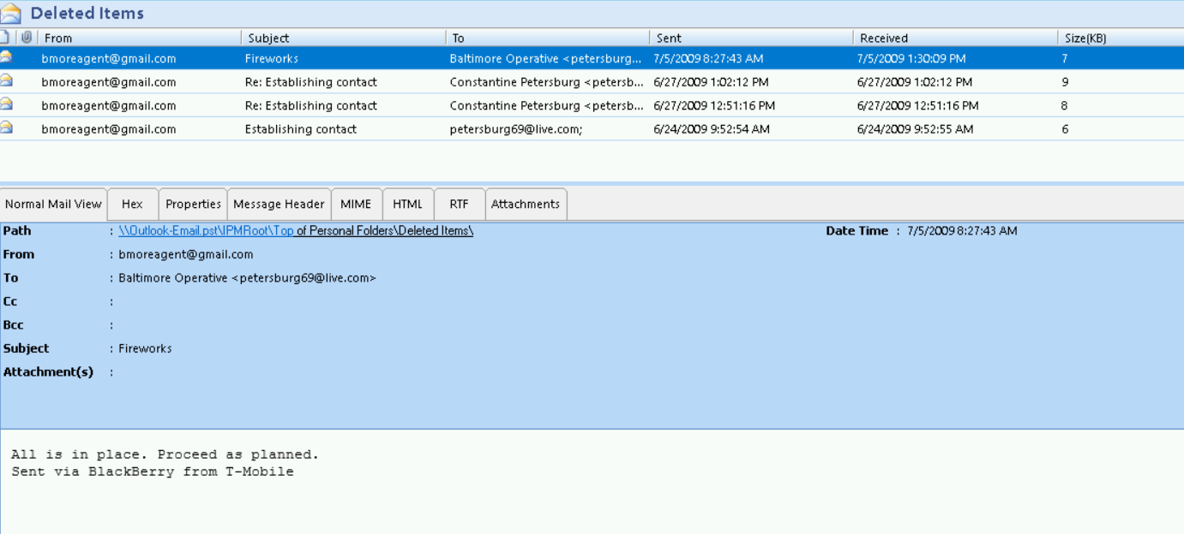

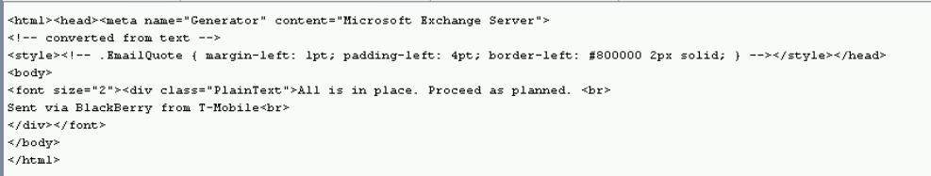

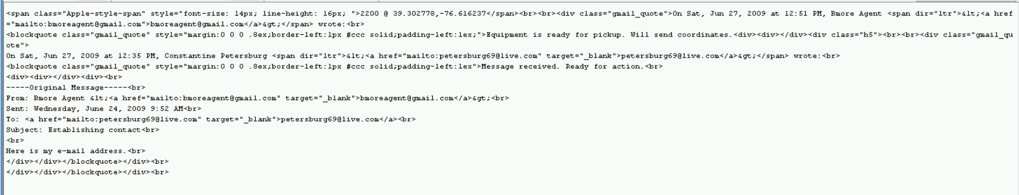

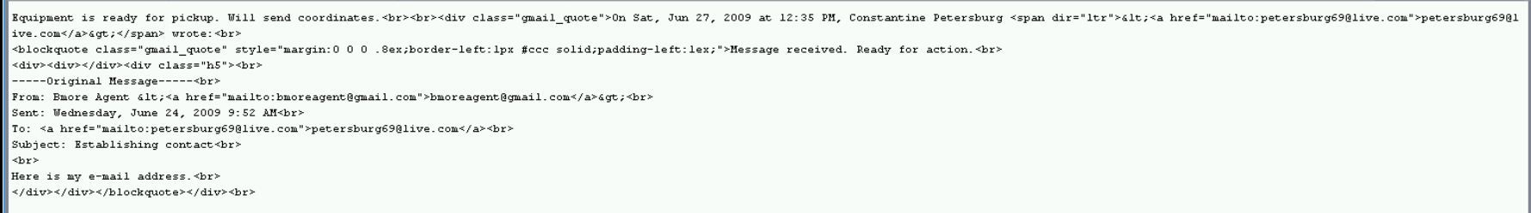

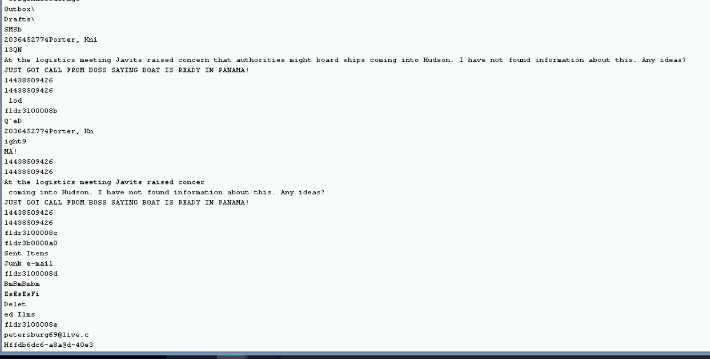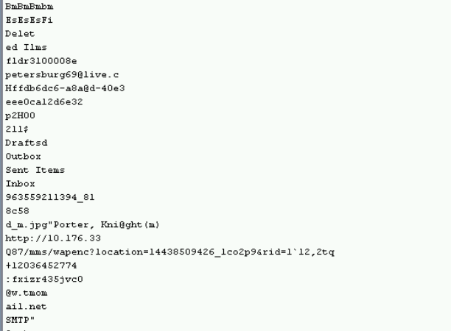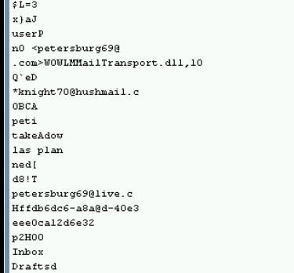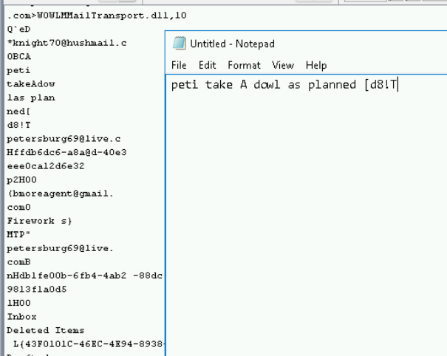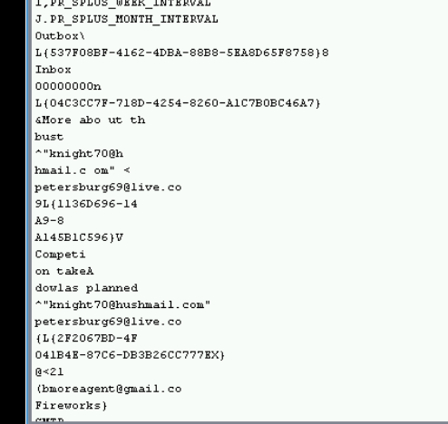

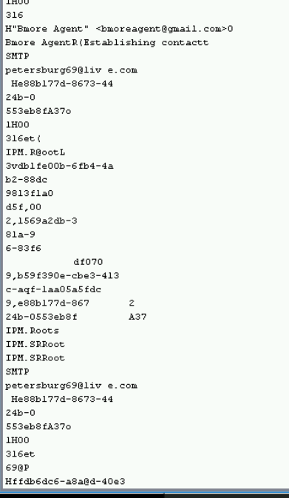

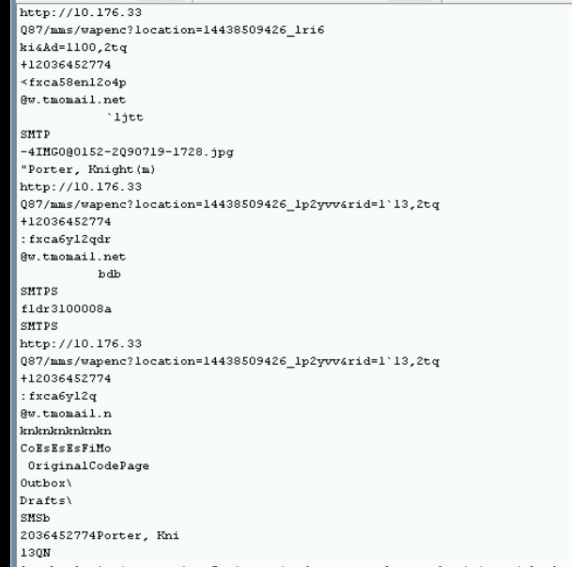

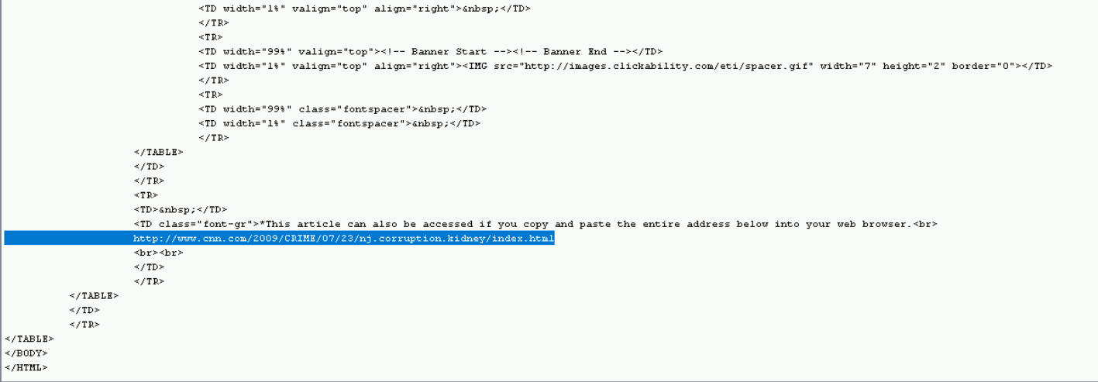

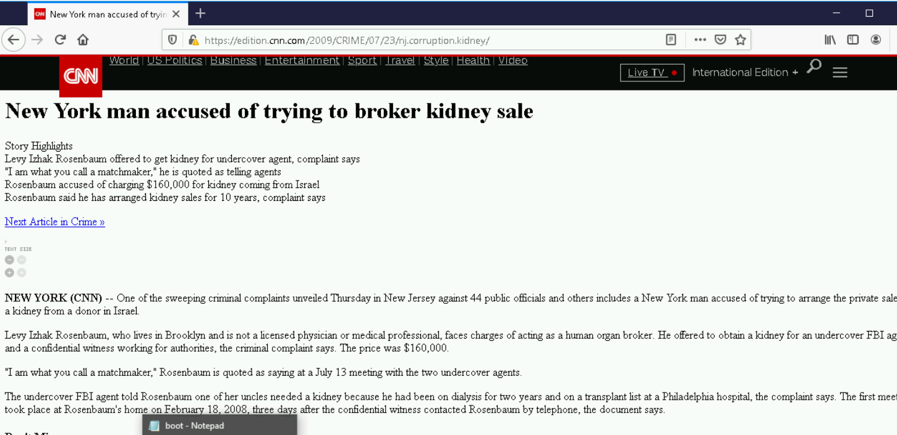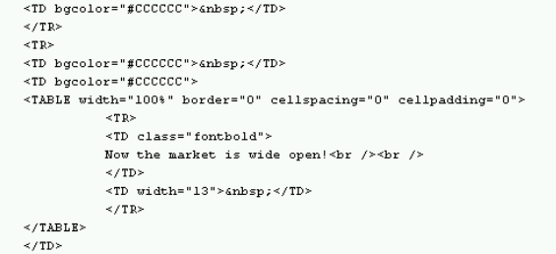

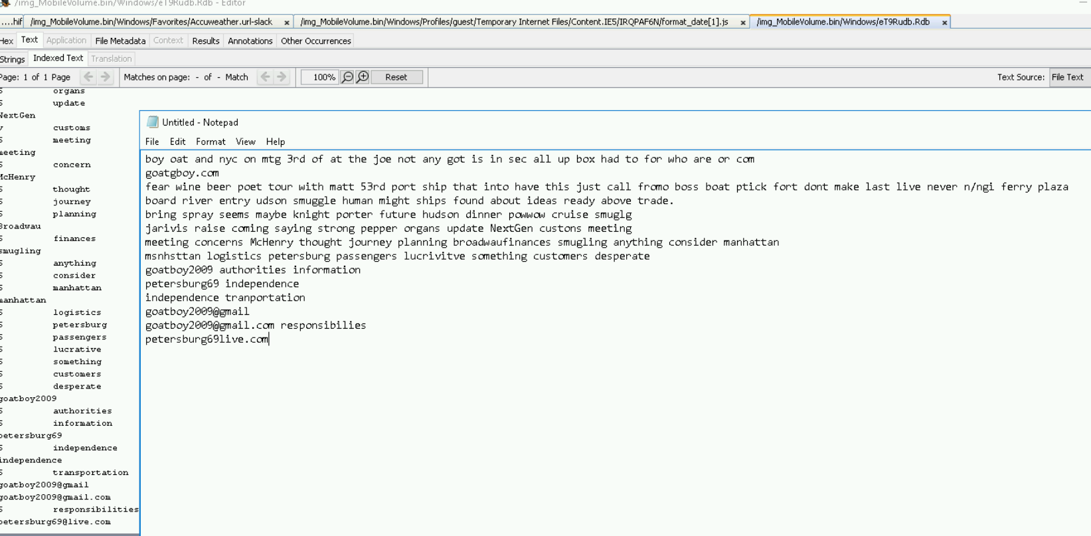

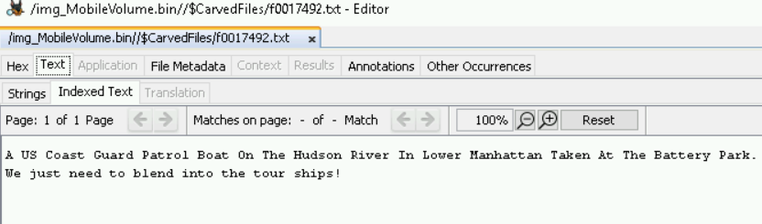

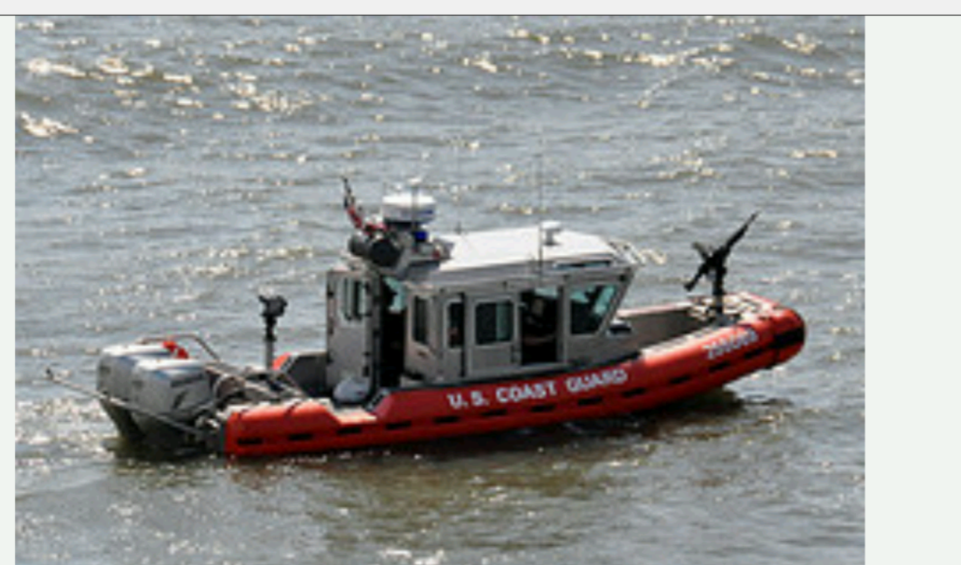

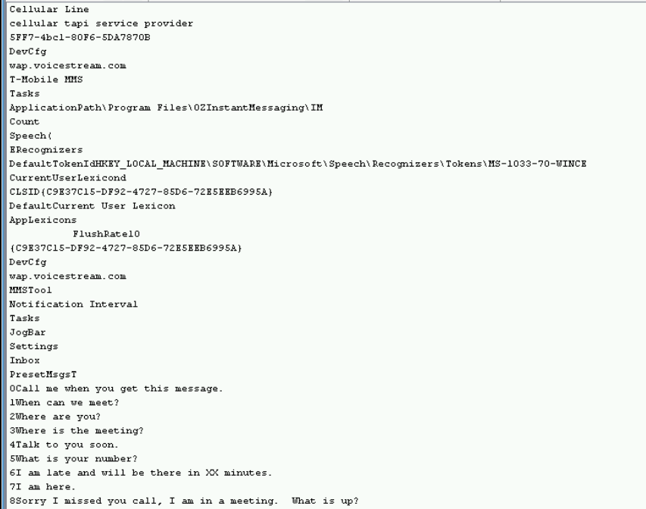

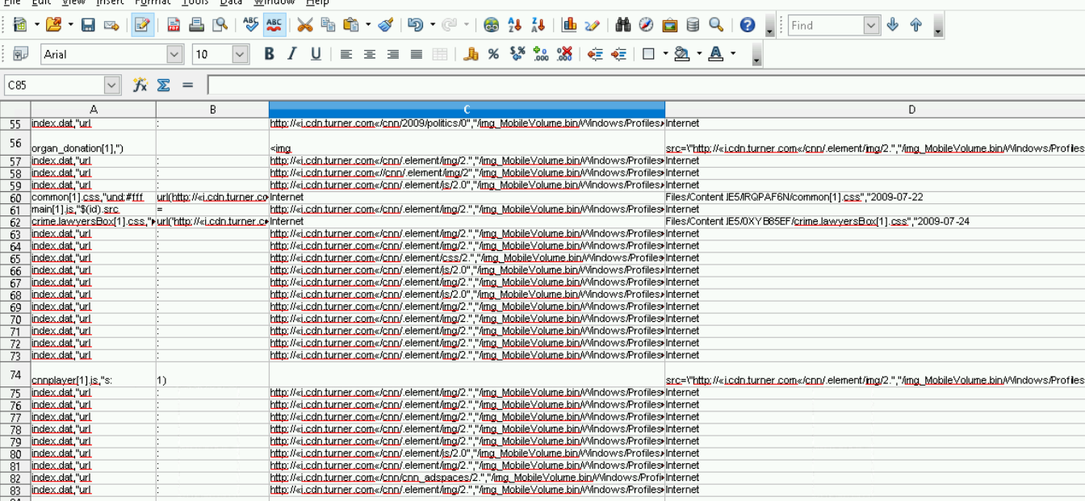

Visted cdn.turner.com 83 times.

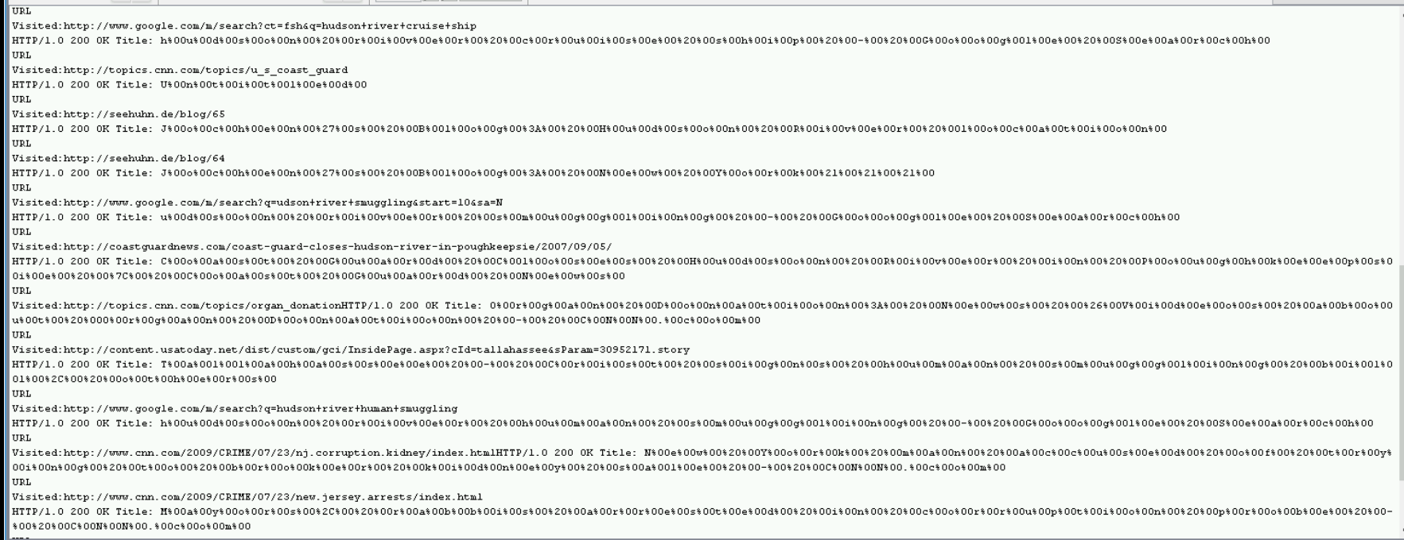

Interesting search history results of smuggling, coast guard shutting down the Hudson, and arrests.

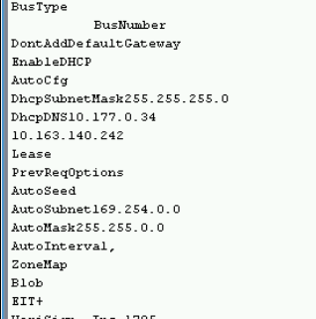 this shows the DHCP Subnet mask (255.255.255.0), the IP addresses(10.177.0.34 and 10.163.140.242) the autosubnet(169.254.0.0) and automask(255.255.0.0) the phone had.

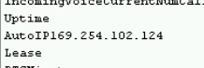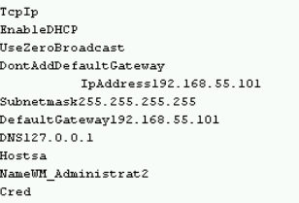

Below are information about a fake TMobile page and codes

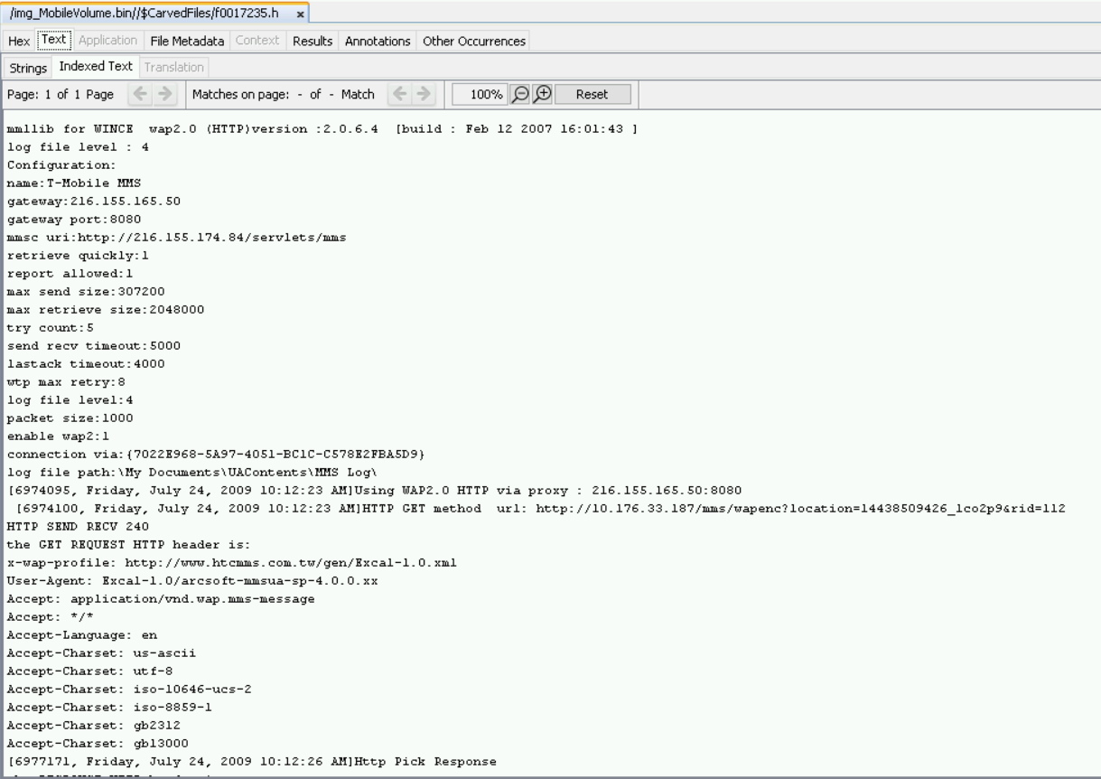

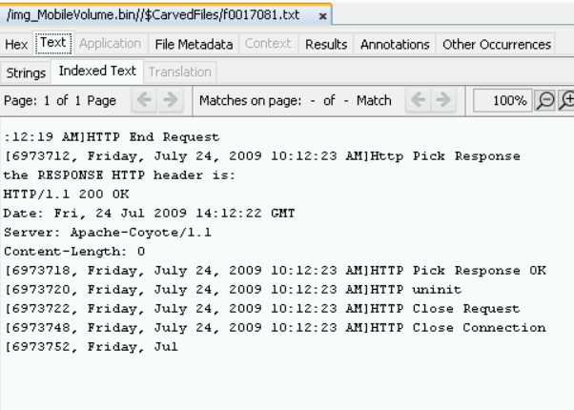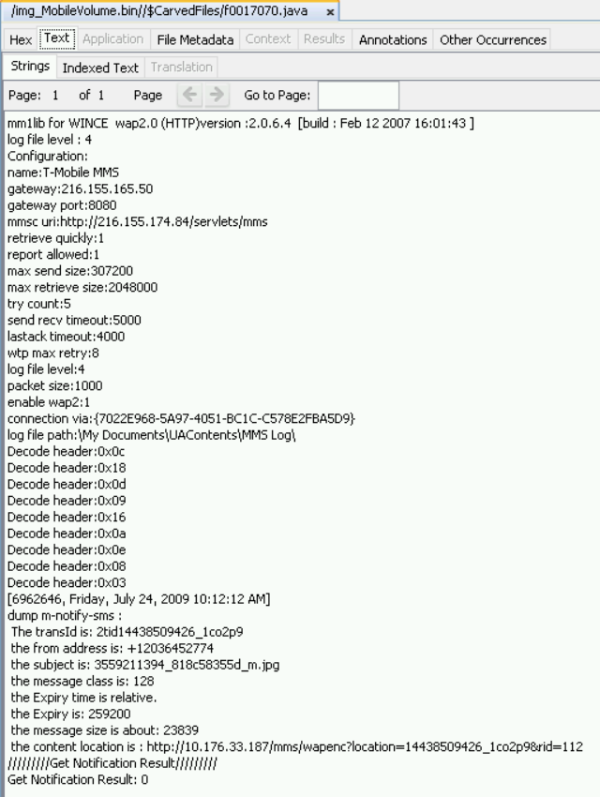

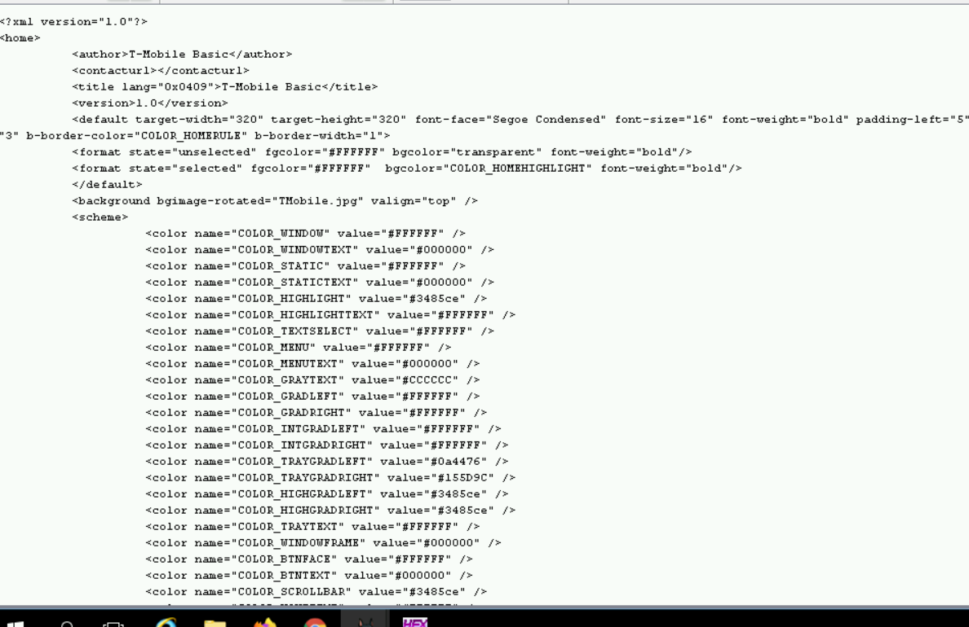

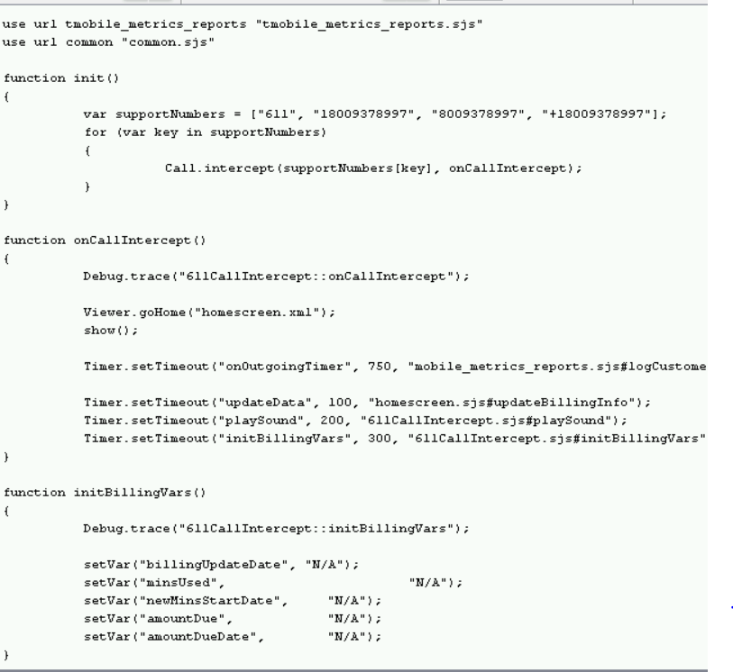



611_message audio file told the user to look at the screen to answer more information

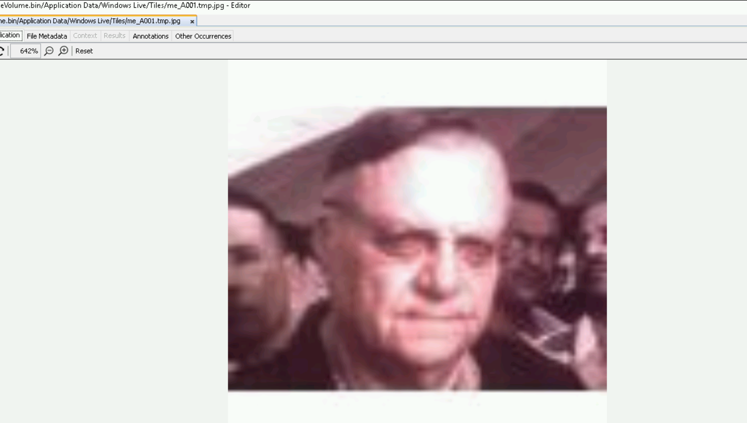maybe picture of Petersburg

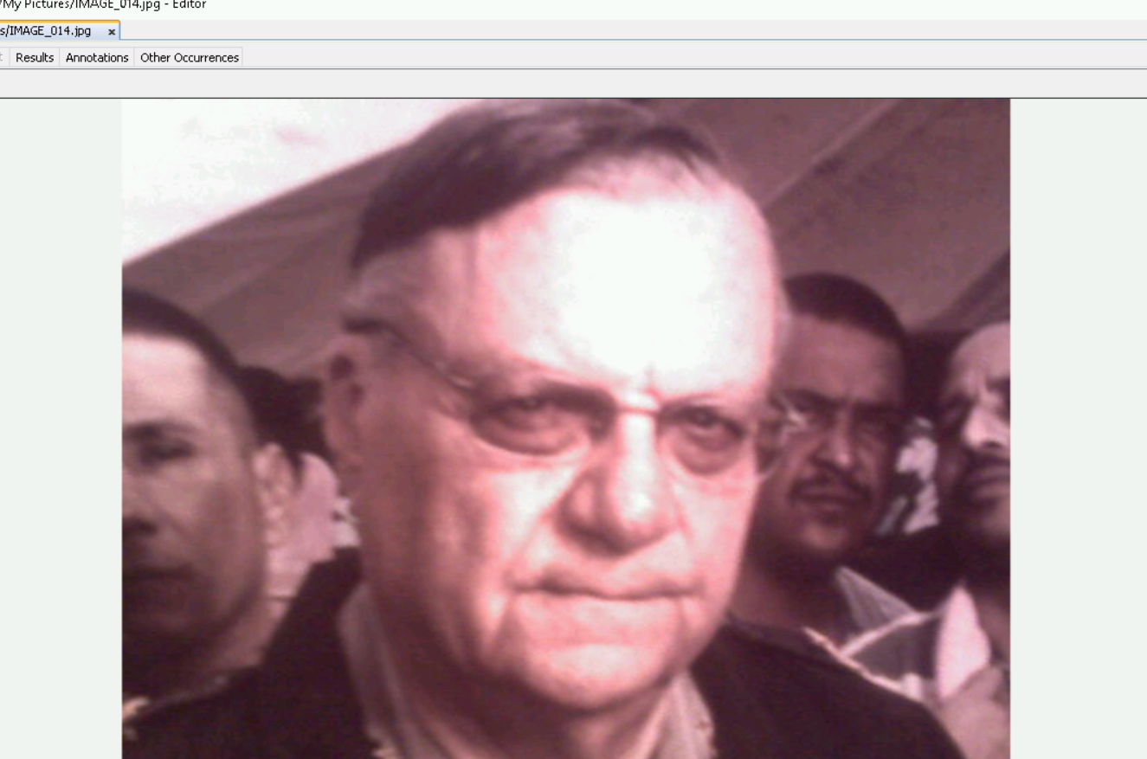a clearer image

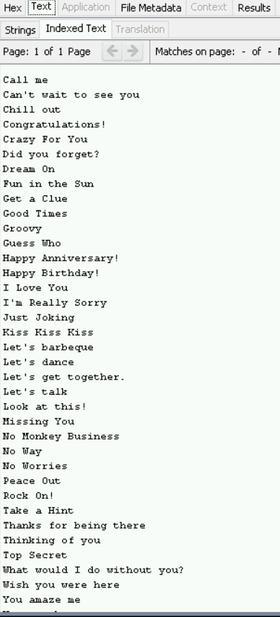

Looks like text messages

